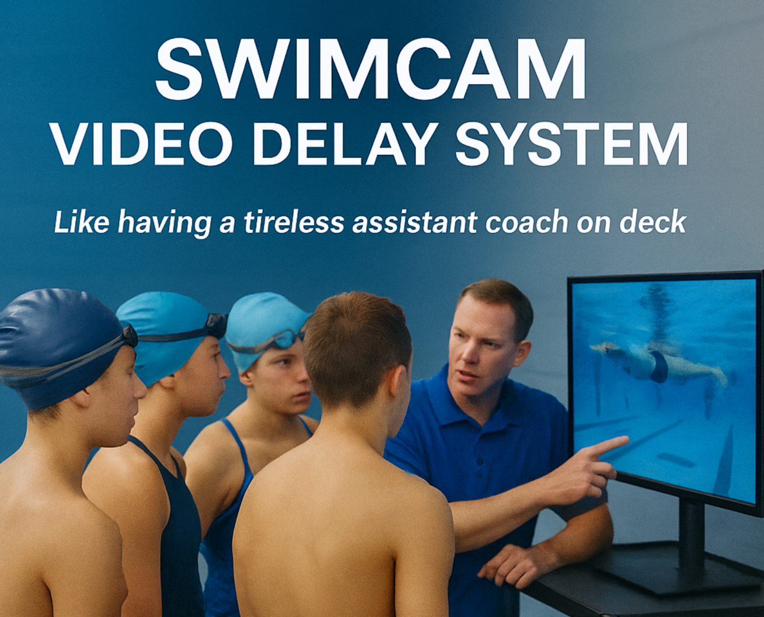

- Each system covers 2 adjacent lanes of swimmers, generating up to 300 feedback units over a 90-minute practice session. (5 swimmers in each lane stopping at the camera end 30 times)
- Works effectively for every swimmer level from Novice to International
- Camera can be positioned above or below the pool surface
- Select any playback delay from 5 seconds to 3 minutes
- Playback at full speed or variable speed slow motion
- No Wi-Fi required, the camera is connected to the system via 90ft cable on a cable reel
- Setup time should not be more than 2 minutes if the system is mounted to a utility cart

System Includes  40 Inch Flat Screen  Custom Camera Stand  Fiberglass Camera Pole  AHD 1080p Camera & 90 Ft Cable  Delay Hardware and Remote Control | - Price: $1,959.00  - 2 Week Free Trial  - Contact us re. Coach Training – Swim Ontario Approved for Pro D Points!  Contact: wrmscoach@gmail.com  519-771-3886

